John Rene Lorelli

Foundations of Data Science

Week 6

Report: Pie Chart

1. The entire R code used when creating the pie chart in (1).

> dogbreeds2017 <- read_csv("dogbreeds2017.csv")

> View(dogbreeds2017)

> install.packages("plyr")

> library(plyr)

> dog<-count(dogbreeds2017, "Breed")

> names(dog)

[1] "Breed" "freq"

> pie(dog$freq, labels=dog$Breed, main="Dog Breeds Pie Chart")

1. Screenshot of the pie chart created in (1).

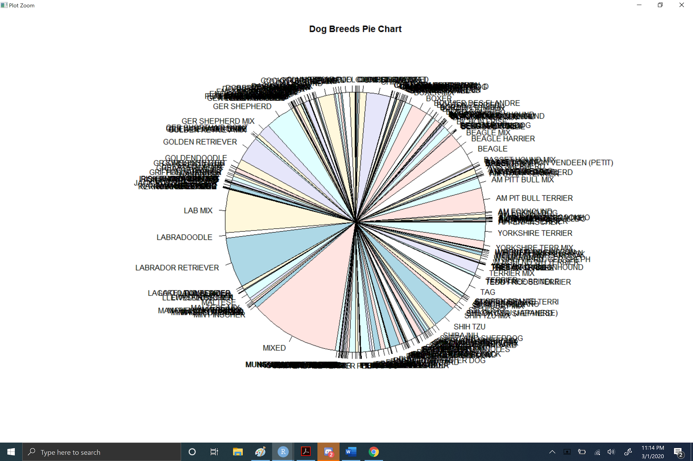

1. A list of problems/weaknesses you see with this pie chart.

* Can not give a clear comparison of amounts
* Deceptive
* Too many breeds and can not read pie chart correctly
* Looks like a mess and can not get any valuable data

1. A list of actions you could incorporate to reduce the identified problems/weaknesses.

More Parameters to hone in on what a person could be looking for

Larger screen to be able to expand the chart

1. The entire R code used when creating the pie chart in (4).

> dogbreeds2017 <- read_csv("dogbreeds2017.csv")

> View(dogbreeds2017)

> install.packages("plyr")

> library(plyr)

> dog<-count(dogbreeds2017, "Breed")

> names(dog)

[1] "Breed" "freq"

> dogsub<-subset(dog, dog$freq > 500)

> pie(dogsub$freq, labels=dogsub$Breed, main="Dog Breed Pie Chart")

1. Screenshot of the pie chart created in (4).

